WRITER ROBOT

DOCUMENTATION

### By

## Benoit Brognaux

## Zijin Nie

## Andi Camille Batie

## Cheng Lin



# TABLE OF CONTENTS

# Design evolution

# Division of labour and Workflow

# Challenges and Roadblocks

# Mechanical designs

# Electrical designs

# Software design

# Design evolution:

Our initial design and how it evolved.

# 2. Division of Labour and Workflow

|  |  |
| --- | --- |
| Member | Responsibilities |
| Benoit Brognaux | * Vehicle frame design * Wheel mounting * Design of supporting leg * Design of servo arm |
| Zijin Nie | * Back-end Java code * Interpretation of user input to interface with Arduino * Design of supporting leg |
| Andi Camille Batie | * Front-end of Java code (GUI) * Interfacing between Java and Arduino * Coding of serial input * Integration of front-end and back-end |
| Cheng Lin | * Servo wiring * DC brushed motors wiring with Pololu motor controller * Arduino IDE code to run servo and motors * Arduino IDE code to interpret serial input from Java |

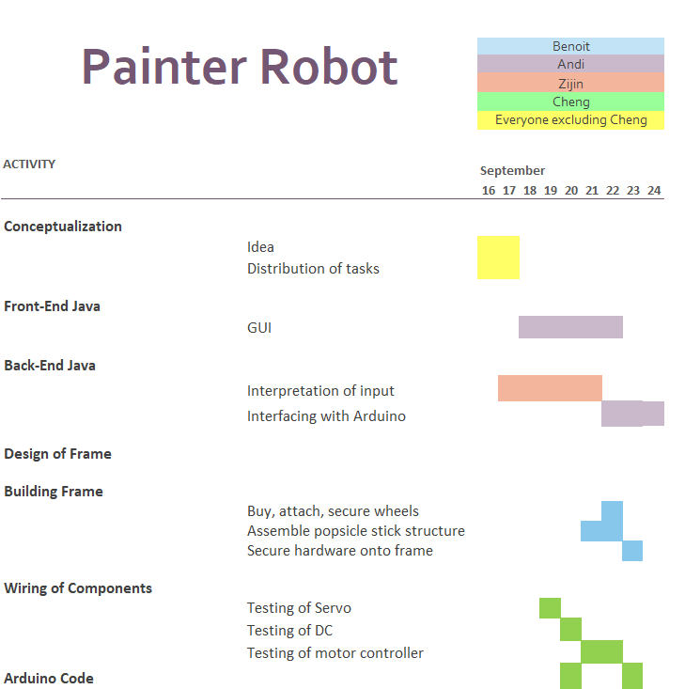

# 3. Challenges and Roadblocks:

The issues we’ve encountered and how we managed to overcome them.

* Motor Driver designed for Raspberry Pi
  + Lack of background, took a while to figure out each pin’s placement
* Awkward breadboard shape
  + Changed design of frame
* Finding and understanding a framework that communicates between java and the serial port
  + Finding example code and researching previous projects
* Lacking material
  + Get creative with what we could replace everything with.

# Mechanical designs (offline)

# Electrical designs

* + <https://www.pololu.com/product/2753>

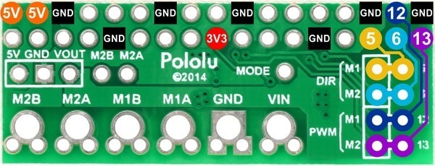

* + https://www.pololu.com/product/2135

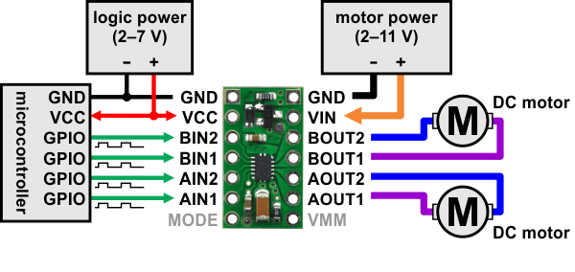

# Software design (see files)

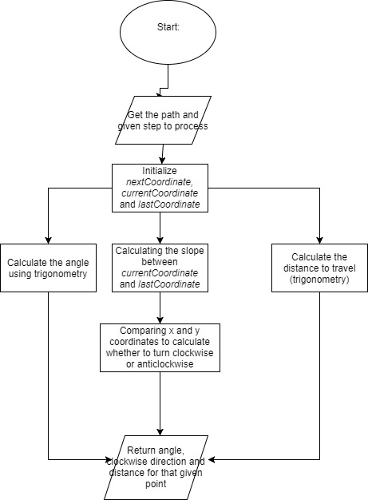

getDegree() flowchart: Function calculates for each step the degree, rotation (clockwise or anticlockwise) and the distance

We used a Model - View - Controller implementati